TW022WA03 and TW022WA04 are compact 22 mm neodymium tweeters for applications where small size is important, while requiring the higest level of performance  The best of two worlds?  The design with 22 mm voice coil and wide surround caters for both applications that would normally require traditional ¾” tweeters and those, where 1” tweeters would usually be used.  Featured with a rear chamber these compact tweeters offer very low resonace frequency.  Innovative  In order to keep distortion and resonance frequency low the TW022WA03/04 are designed around an outside neodymium ring magnet in order to allow for a larger internal volume than that of traditional neodymium tweeter.  The dome shape and material choice allow for almost full output level to beyond 40 kHz.  The only difference between the two models is that TW022WA04 is shipped with an optimized face plate attached while TW022WA03 comes without face plate, for direct mounting in the enclosure/baffle.  FEATURES | TW022WA04  Frequency resp.  Specifications  Dimensions  Ordering info

- 22 mm design for optimal compromise between on- and off-axis frequency response, resonance frequency, and power handling
- Rear chamber for low resonance frequency and reduced distortion
- Outside ring neodymium magnet for lower resonance frequency and distortion
Precision-coated textile diaphragm for improved consistency and high-frequency extension
- Optimized dome shape for ultra high frequency cutoff
- Vented voice coil former for reduced distortion and compression
- Copper-clad aluminium voice coil wire offering lower moving mass for improved efficiency and transient response
- Build-in cavities under dome/edge to equalize pressure for lower distortion and lower resonance frequency
- Flexible lead wires for higher power handling and larger excursion
- Gold plated terminals to prevent oxidation and ensure long-term reliable connection
- Delivered with foam gasket attached for hassle-free mounting and secure cabinet sealing (TW022WA04 only)

SPL FREQUENCY RESPONSE

Measuring conditions, SPL
Driver mounting: Flush in infinite baffle
Microphone distance: 1.0 m
Input level: 2.83 VRMS
Smoothing: 1/6 oct.

IMPEDANCE RESPONSE

Measuring conditions, impedance
Driver mounting: Free air, no baffle
Input signal: Stepped sine wave, semi-current-drive, nominal current 2 mA
Smoothing: None

NOMINAL SPECIFICATIONS

Notes | Parameter | Value | Unit
 | Nominal size | 22 | [mm]
 | Nominal impedance | 4 | [ohm]
 | Recommended frequency range | 2 - 30 | [kHz]
1, 4 | Sensitivity, 2.83V/1m (average SPL in range 2 - 20 kHz) | 89 | [dB]
2 | Power handling, short term, IEC 268-5, 3.0kHz@12dB/oct. |  | [W]
2 | Power handling, long term, IEC 268-5, 3.0kHz@12dB/oct. |  | [W]
2 | Power handling, continuous, IEC 268-5, 3.0kHz@12dB/oct. |  | [W]
6 | Effective radiating area, Sd | 6.1 | [sq.cm]
3, 4 | Resonance frequency (free air, no baffle), Fs | 800 | [Hz]
7 | Moving mass, incl. air (free air, no baffle), Mms | 0.27 | [g]
3 | Force factor, Bxl | 1.7 | [N/A]
3, 4 | Suspension compliance, Cms | 0.15 | [mm/N]
3, 4 | Equivalent air volume, Vas | 7.7 | [ml]
3, 4 | Mechanical resistance, Rms | 0.97 | [Ns/m]
3, 4 | Mechanical Q, Qms | 1.4 | [-]
3, 4 | Electrical Q, Qes | 1.69 | [-]
3, 4 | Total Q, Qts | 0.77 | [-]
4 | Voice coil resistance, RDC | 3.6 | [ohm]
5 | Voice coil inductance, Le (measured at 20 kHz) | 40 | [μH]
 | Voice coil inside diameter | 22 | [mm]
 | Voice coil winding height | 1.6 | [mm]
 | Air gap height | 2.5 | [mm]
 | Theoretical linear motor stroke, Xmax | ±0.45 | [mm]
 | Magnet weight |  | [g]
 | Total unit net weight excl. packaging |  | [kg]
3, 5 | Krm |  | [mohm]
3, 5 | Erm |  | [-]
3, 5 | Kxm |  | [mH]
3, 5 | Exm |  | [-]

Note 1 | Measured in infinite baffle.
Note 2 | Tested in free air (no baffle)
Note 3 | Measured using a semi-constant current source, nominal level 2 mA.
Note 4 | Measured at 25 deg. C
Note 5 | It is generally a rough simplification to assume that loudspeaker transducer voice coils exhibit the characteristics of an inductor. Instead it is a far more accurate approach to use the more advanced model often referred to as the “Wright empirical model”, also used in LEAP-4 as the TSL model (www.linearx.com), involving parameters Krm, Erm, Kxm, and Exm. This more accurate transducer model is described in a technical paper (PDF) here.
Note 6 | Calculated as the area inside the middle of the surround.
Note 7 | Determined by physical weighing of the moving parts including the inner half of the surround.

OUTLINE DRAWING AND NOMINAL DIMENSIONS, TW022WA03 (mm)

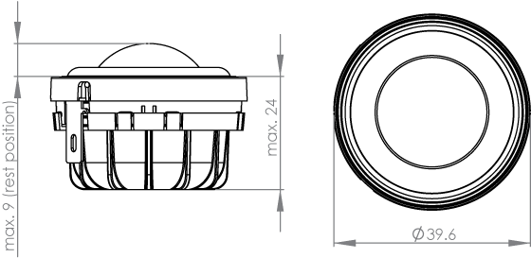

OUTLINE DRAWING AND NOMINAL DIMENSIONS, TW022WA04 (mm)

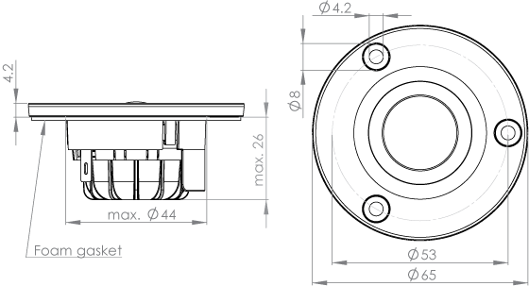

TERMINAL NOMINAL DIMENSIONS (mm)

