PR178WA01 is a passive unit designed for dedicated subwoofer applications - as a partner to our active subwoofer units.
Due to low mechanical losses PR178WA01 masters equally well low level details and extreme dynamic requirements.
For demanding subwoofer applications using a passive unit is usually the only real alternative to sealed enclosures with active bass boost.
To make experimenting and individual tuning convenient and easy, the PR178WA01 is delivered with three separate extra loads that are easily applied onto a threaded rod on the rear side of the cone (see picture below).
FEATURES

- Extremely rigid aluminium cone for precise transient response
- Very low mechanical losses
- Rear M6 threaded rod for trouble-free and rigid addition of extra mass
- Delivered with three separate mass loads for easy custom tuning

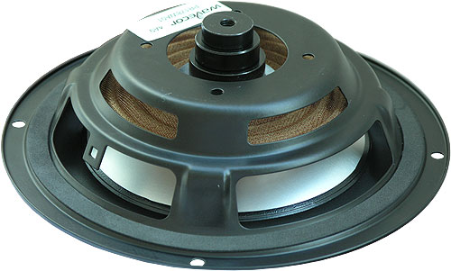
All 3 extra weights added at the same time (+35g)
ADDING MASS
Extra mass is easily added on the rear (see picture above). Either one, two or all three included mass loads can be added, or any custom mass object can be added simply using an M8 nut for fastening. The loads included with PR178WA01 do not require any nuts as they are made with M8 threaded center holes.
For experiments trying out different values of moving mass for different tunings, it is usually sufficient just to tighten the loads/nut by hand.
Once the final mass has been determined it is recommend to add some adhesive to secure the loads from coming loose during operation.
NOMINAL SPECIFICATIONS
Nominal size | 7 | [inch.]
Effective radiating area, S_{d} | 131 | [sq.cm]
Resonance freq., Fs, without additional mass  - with additional 5g mass  - with additional 10g mass  - with additional 15g mass  - with additional 20 g mass  - with additional 25g mass  - with additional 30g mass  - with additional 35g mass | 26  24.8  23.7  22.8  22.0  21.2  20.6  19.9 | [Hz]  [Hz]  [Hz]  [Hz]  [Hz]  [Hz]  [Hz]  [Hz]
Moving mass, incl. air, without extra weight  (may be be increased in 5g steps from +5g to +35g) | 50 | [g]
Suspension compliance, C_{ms} | 0.70 | [mm/N]
Equiv. air volume, V_{as} | 17 | [lit.]
Mechanical Q, Q_{m}, without additional mass | 24 | -
Total unit net weight (incl. 3 extra weights) | 0.25 | [kg]

OUTLINE DRAWING AND NOMINAL DIMENSIONS (mm)

