TW030WA09 and TW030WA10 are tweeters designed for applications requiring the highest level of performance, with extended and linear high frequency response and best consistency.  Innovation  Tweeters used to feature a separate rear chamber in order to obtain low resonance frequency. Not any longer. By designing the internal parts to accommodate new larger internal volumes, the TW030WA09/10 offer an unusually low resonance frequency.  FEATURES | Frequency resp.  Specifications  Dimensions  Ordering info

- 30 mm design with controlled off-axis and power response, high power handling, and low resonance frequency
- Internal volumes for low resonance frequency and distortion
- Precision-coated textile diaphragm for improved consistency and high-frequency extension
- Optimized dome shape for ultra high frequency cutoff
- Vented voice coil former for reduced distortion and compression
- Copper-clad aluminium voice coil wire offering lower moving mass for improved efficiency and transient response
- Build-in cavities under dome/edge to equalize pressure for lower distortion and lower resonance frequency
- Flexible lead wires for higher power handling and larger excursion
- Gold plated terminals to prevent oxidation and ensure long-term reliable connection
- Delivered with foam gasket attached for hassle-free mounting and secure cabinet sealing

FREQUENCY RESPONSE

Measuring conditions, SPL  Driver mounting: Flush in infinite  baffle, back side open (no cabinet)  Microphone distance: 1.0 m  Input level: 2.83 VRMS  Smoothing: 1/6 oct. | Measuring conditions, impedance  Driver mounting: Free air, no baffle,  back side open (no cabinet)  Input signal: Semi-current-drive,  nominal current 2 mA  Smoothing: None

Measuring conditions, SPL  Driver mounting: Flush in infinite  baffle, back side open (no cabinet)  Microphone distance: 1.0 m  Input level: 2.83 VRMS  Smoothing: 1/6 oct. | Measuring conditions, impedance  Driver mounting: Free air, no baffle,  back side open (no cabinet)  Input signal: Semi-current-drive,  nominal current 2 mA  Smoothing: None

NOMINAL SPECIFICATIONS

Notes | Parameter | TW030WA09 | TW030WA10 | Unit
 | Nominal size | 30 | 30 | [mm]
 | Nominal impedance | 4 | 8 | [ohm]
 | Recommended frequency range | 2 - 27 | 2 - 27 | [kHz]
1, 4 | Sensitivity, 2.83V/1m (average SPL in range 2 - 20 kHz) | 92.5 | 90 | [dB]
2 | Power handling, short term, IEC 268-5, 2.5 kHz@12dB/oct. |  |  | [W]
2 | Power handling, long term, IEC 268-5, 2.5 kHz@12dB/oct. |  |  | [W]
2 | Power handling, continuous, IEC 268-5, 2.5 kHz@12dB/oct. |  |  | [W]
 | Effective radiating area, S_{d} | 11.5 | 11.5 | [sq.cm]
3, 4, 6 | Resonance frequency (free air, no baffle), F_{s} | 725 | 750 | [Hz]
 | Moving mass, incl. air (free air, no baffle), M_{ms} | 0.45 | 0.42 | [g]
3 | Force factor, Bxl | 2.0 | 2.4 | [N/A]
3, 4, 6 | Suspension compliance, C_{ms} | 0.11 | 0.11 | [mm/N]
3, 4, 6 | Equivalent air volume, V_{as} | 0.020 | 0.020 | [lit.]
3, 4, 6 | Mechanical resistance, R_{ms} | 0.25 | 0.25 | [Ns/m]
3, 4, 6 | Mechanical Q, Q_{ms} | 8.1 | 7.8 | [-]
3, 4, 6 | Electrical Q, Q_{es} | 1.74 | 2.17 | [-]
3, 4, 6 | Total Q, Q_{ts} | 1.43 | 1.70 | [-]
4 | Voice coil resistance, R_{DC} | 3.4 | 6.3 | [ohm]
5 | Voice coil inductance, L_{e} (measured at 20 kHz) |  |  | [μH]
 | Voice coil inside diameter | 30.4 | 30.4 | [mm]
 | Voice coil winding height | 1.7 | 1.7 | [mm]
 | Air gap height | 2.5 | 2.5 | [mm]
 | Theoretical linear motor stroke, Xmax | ±0.40 | ±0.40 | [mm]
 | Magnet weight |  |  | [g]
 | Total unit net weight excl. packaging |  |  | [kg]
3, 4, 5 | K_{rm} |  |  | [mohm]
3, 4, 5 | E_{rm} |  |  | [-]
3, 4, 5 | K_{xm} |  |  | [mH]
3, 4, 5 | E_{xm} |  |  | [-]

Note 1 | Measured in infinite baffle.
Note 2 | Tested in free air (no cabinet).
Note 3 | Measured using a semi-constant current source, nominal level 2 mA.
Note 4 | Measured at 25 deg. C
Note 5 | It is generally a rough simplification to assume that loudspeaker transducer voice coils exhibit the characteristics of an inductor. Instead it is a far more accurate approach to use the more advanced model often referred to as the “Wright empirical model”, also used in LEAP-4 as the TSL model (www.linearx.com), involving parameters Krm, Erm, Kxm, and Exm. This more accurate transducer model is described in a technical paper (PDF) here.
Note 6 | Measured before burn in

OUTLINE DRAWING AND NOMINAL DIMENSIONS (mm)

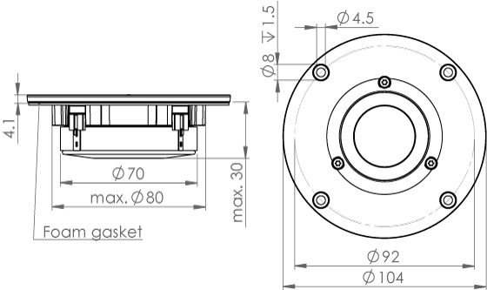

TERMINAL NOMINAL DIMENSIONS (mm)
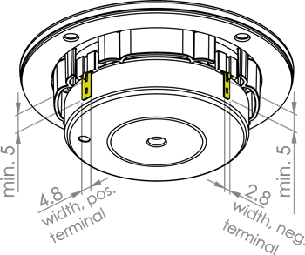
Thickness, both terminals: 0.5 mm
Terminal plating: Gold

